BIOMASS COOKSTOVE DMRV SYSTEM - USER MANUAL

1. Introduction
The device monitors the temperature and location of cookstove usage for performance and usage analytics. It utilizes an ESP32 microcontroller, GPS module, MAX6675 thermocouple, and SD card module to log temperature and location data. When internet connectivity is available, the data is automatically uploaded to a Google Sheet. Otherwise, it is stored locally on the SD card for later synchronization.

2. Safety Precautions
- Use only the Type-C charging input — do not connect power directly to the battery.
- Avoid short-circuiting the battery terminals.
- Do not disassemble or modify the BMS circuitry.
- Stop usage immediately if the battery becomes hot or swollen.
- Keep the device in an environment between 20°C and 45°C.

3. Product Overview
The system detects cookstove usage by sensing temperature rise above a set threshold (60°C). When activated, it records temperature and GPS location data every 5 minutes. The data is logged in the SD card and uploaded to a Google Sheet when Wi-Fi becomes available.

4. Hardware Components
- ESP32-WROOM-32 (Main microcontroller)
- NEO-M8N GPS Module
- MAX6675 Thermocouple Sensor
- SD Card Module + microSD (4GB)
- 3 × 18650 Li-ion cells (3S configuration)
- Inbuilt BMS circuit for charging/discharging management
- Type-C charging module
- Buck Converter for regulated power supply (5V to 3.3V)
- LEDs and power switch
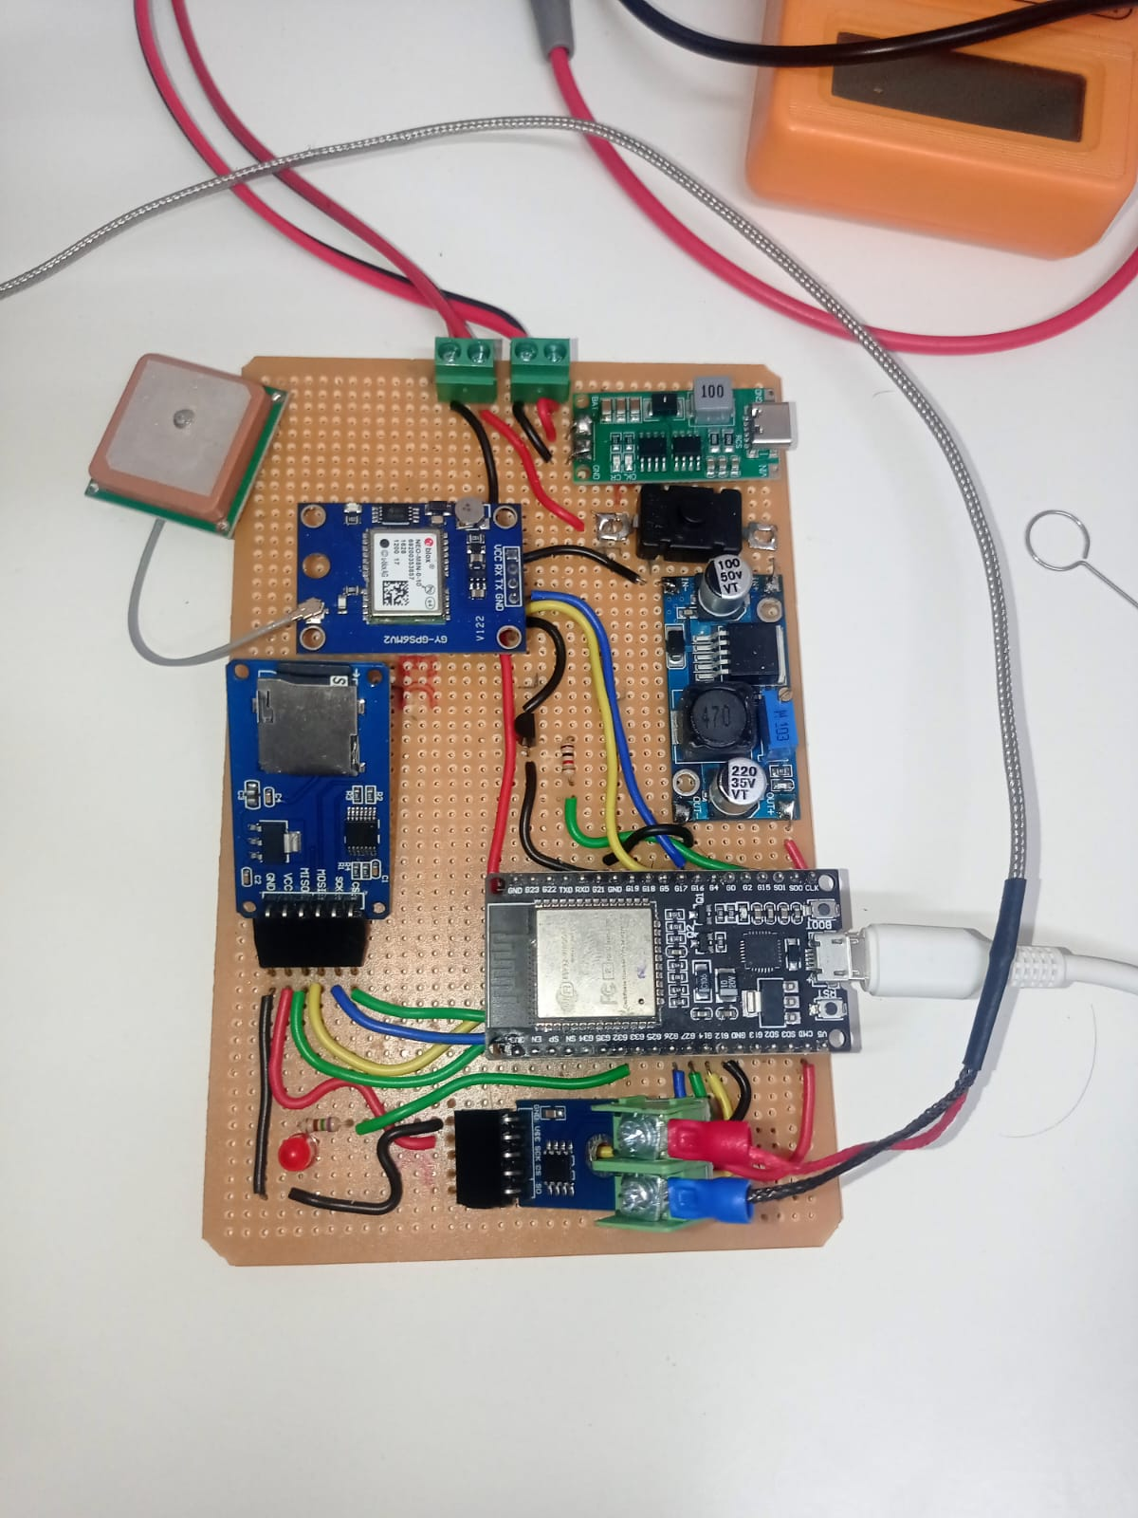

5. Technical Specifications
Input Power: 5V DC via USB Type-C or 3S Li-ion battery pack (11.1V nominal)
Charging Circuit: Integrated BMS with overcharge/discharge protection
Battery Capacity: 3 × 2200mAh (approx. 6600mAh total)
Charging Input: Type-C 5V/2A
Charging Time: 3–3.5 hours
Communication: Wi-Fi (2.4GHz) and GPS
Data Logging Interval: 5 minutes
Sensor: MAX6675 (0°C–1024°C)
Storage: microSD card (4GB)
- Charging Instructions
- Connect adapter using a Type-C cable.
2. The inbuilt BMS manages balanced charging and protection.
3. Red LED on the charging module indicates charging; Green LED indicates full charge.
4. The system can safely operate while charging.
5. Avoid using non-standard power adapters or cables.

7. Operation Instructions
1. Ensure the battery is adequately charged or connect external power.
2. Switch ON the power button to start the device.
3. The ESP32 initializes all connected modules.
4. The temperature sensor monitors the cookstove.
5. When temperature exceeds 60°C, GPS is activated, and data is logged.
6. The data includes timestamp, temperature, latitude, and longitude.
7. When Wi-Fi becomes available, the logged data is uploaded automatically to the cloud (Google Sheet).

8. LED Indicators
Power LED: Device ON
Wi-Fi LED: Indicates active Wi-Fi connection
Red LED: Momentarily on Every 5 minutes > Module is in active/on
Sleep LED: Blinks 5 times when entering deep sleep mode

9. Data Logging and Upload
The device logs data into the SD card in CSV format, containing the following fields:
Timestamp, Prototype ID, Cycle Count, Temperature, Latitude, Longitude, and Google Maps Link.
If Wi-Fi connectivity is detected, data is automatically uploaded to the linked Google Sheet.

10. Maintenance
• Keep the thermocouple sensor clean and free of carbon deposits.
• Recharge the battery every 2–3 days of continuous use.

11. Troubleshooting
Issue: Device not turning ON
→ Check the power switch and battery voltage.
Issue: No data on SD card
→ Ensure SD card is inserted properly and formatted.
Issue: Data not uploading online
→ Verify Wi-Fi credentials and internet availability.

